Website Landing Page
Saint Leo University

Website

Communication: | PayMyTuition instruction page for school website.
Purpose: | Introduce international students to the PayMyTuition payment portal as the preferred payment method for international students.

Preferred payment method for international students:
Saint Leo University has partnered with PayMyTuition for international tuition payments. With PayMyTuition, you can pay your tuition payments from any bank, in any country in any currency at better than bank exchange rates. PayMyTuition is fast, simple and cost effective.
How to Make a Payment:
- Go to https://saintleo.okta.com and select the “Elion Self Service” app.
- Select “Student Finance” from the left navigation panel and click on “Make a Payment.”
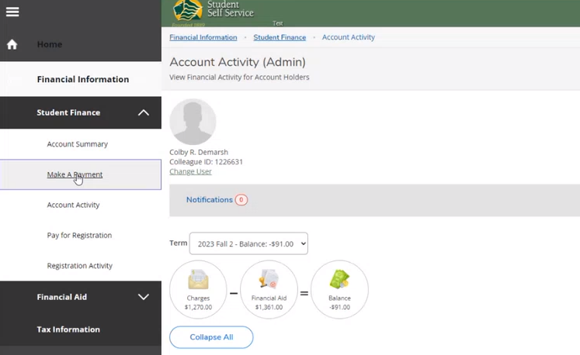

- Select “Click to submit your payment today!” from the International Students section to be redirected to the PayMyTuition payment portal.
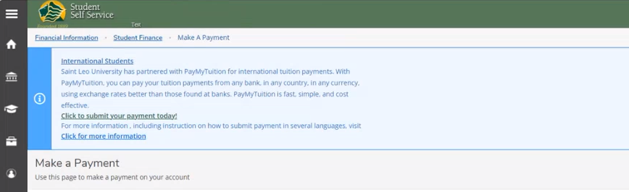

Alternatively, you can select the “Pay now with PayMyTuition” button below to be redirected to your payment portal.
{Please link button above to your payment portal page with PayMyTuition} https://www.paymytuition.com/paynow/saint-leo
Additional Information on PayMyTuition:
- PayMyTuition’s Rate Guarantee
- Frequently Asked Questions
How to make a payment – step-by-step PDFs:
{Link to Payment Steps PDF after uploading on your server}
- English

PayMyTuition customer support information
Call 1.855.663.6839 (toll-free) or through one of their local country contact numbers. You can also reach PayMyTuition Support at support@paymytuition.com or through their support page.
No matter what time zone you're in, you will have a dedicated customer support team available to you through live chat, email and phone to answer any of your questions and help you make your payment.

